Assignment 22.
- Difference between select single and select up to 1 row
- SELECT SINGLE:
- Fetches one record based on primary key or unique condition.
- SELECT SINGLE is used when you know exactly one record exists (like using primary key).
- SELECT SINGLE * FROM zemp
- INTO ls_emp
- WHERE emp_id = 101.
- SELECT UP TO 1 ROWS:
- Fetches first matching record from the result set (not necessarily unique).
- SELECT UP TO 1 ROWS is used when multiple records may exist, but you only want one record.
- SELECT * FROM zemp
- INTO ls_emp
- UP TO 1 ROWS
- WHERE dept = 'IT'.
- ENDSELECT.
# | Point | SELECT SINGLE | SELECT UP TO 1 ROWS
1 | Purpose | Designed for primary key lookup | Designed for any condition based lookup
2 | ORDER BY | Not allowed | Allowed
3 | Result Type | Result goes into a Structure | Result goes into an Internal Table
4 | Row Selection | If key is incomplete, picks random row | Always picks first row after sorting — predictable
5 | Syntax Style | Older classic ABAP syntax | Modern recommended syntax

- Disadvantages of inner join and Advantages of for all entries?
- INNER JOIN returns only matching records from both tables based on a common field.
- Disadvantages:
- If any table has no matching record, that row is completely excluded from result
- Performance is slow when joining large tables
- Cannot use aggregate functions easily with complex joins
- More database load — join happens at DB level
- FOR ALL ENTRIES is used to fetch data from a database table based on values from an internal table.
- Advantages:
- Faster performance — fetches only required records based on internal table
- Works like a dynamic WHERE clause — filters using your internal table values
- Less DB load — we control what data to fetch
- Useful when data is already in an internal table from a previous SELECT
- Better for large data sets compared to inner join
- INNER JOIN may lead to data loss and performance issues for large datasets, whereas FOR ALL ENTRIES provides better flexibility and can improve performance by using internal tables to fetch required data.

- practice select query using 3 table and using inner join?
- An INNER JOIN with 3 tables is used to combine data from three database tables where matching records exist in all tables.

- we have 3 tables to perform inner join
- ZKR_DT_DEPTABLE1
ZKR_DT_EMPTABLE1
ZKR_DT_salary1
- 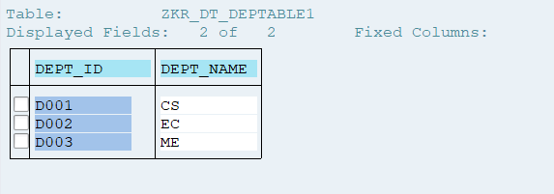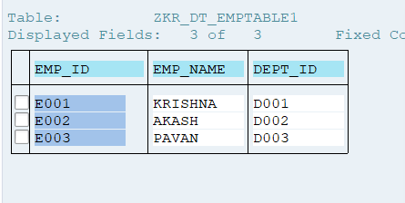
- 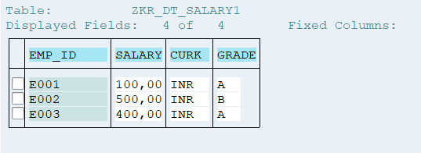
- 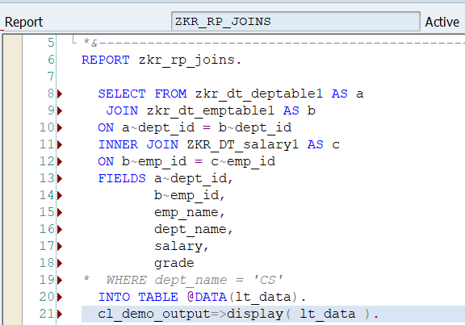
- Output:
- 